Hi,   
  
Hope you are doing well. Purpose of this document is to explain working of Dow Jones API as well as purposed solution to work with Dow Jones in CRM.

1. This is the link to access Dow Jones **Risk center database.** [Dow Jones Risk & Compliance ..](https://djrc.dowjones.com/EntityDetailsInternet.aspx?PersonEntityID=QTMSOYHjsp6bHp2Osra4CYcJnZnjfUl/nRPUNRIPwDx+o1LZDMI=&iProductTypeID=QTMSOYHjSHxeZnt8pUInLrMrHZ4+LOaXwuccVki/AEWH1zdr57A=&navigation=QTMSOYHjnx91u5Ush02vYUXnmiKH1HoR8YA5KsT7eFg7on7v960=&NameValue=1) for better understanding Dow Jones.
2. I have explored Dow Jones two API’s (Risk and compliance API and Screening and Monitoring API) and below is the procedure to work with Dow Jones API to fulfil our requirements.

* We need to add case, which is basically a request to Dow Jones Risk center database to return results as per our added **content-categories** by adding unique name to case and adding **content categories** from where we are supposed to grab data. Below are different content-categories which we can use while adding cases.

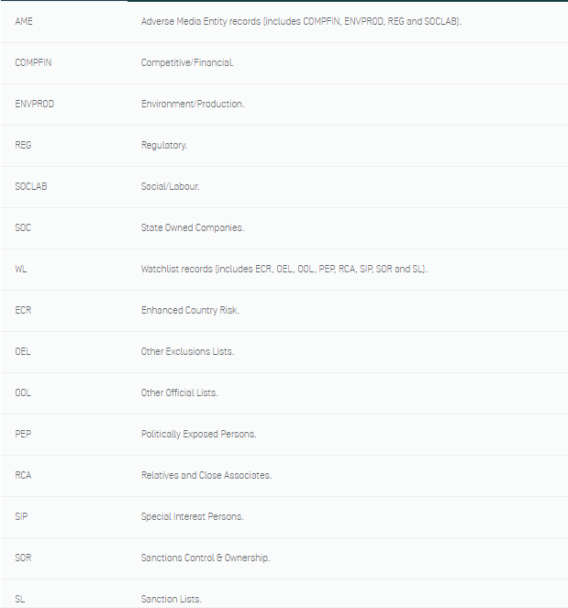

* We need to add association, Association is of two types.

1. Person

For person, we are supposed to add gender, first-name, last-name, year-of-birth, industry sector code, as well as unique name for association. Below is the sample association for person.

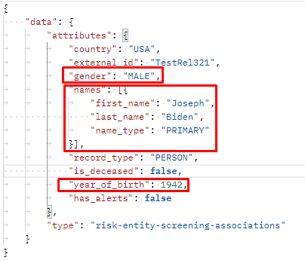

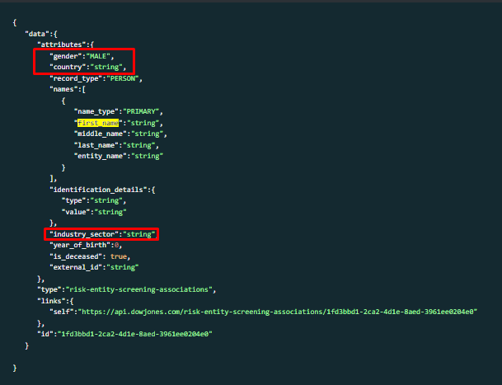

1. Entity

For Entity, we are supposed to pass entity name, country code, industry sector and association unique identifier.

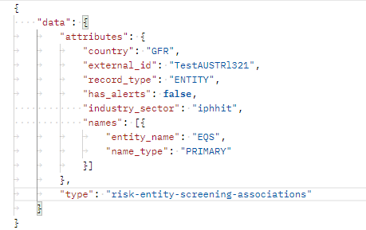

* We need to link association with added case to get better results.

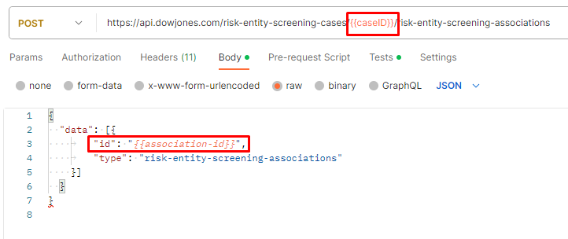

Once we link association with case, next step is to grab the **matched results**

* For matched results, we get profiles_ids from Dow Jones risk center (Profiles_ids are basically filtered results of our added case and association)
* Next step is to search for profiles using profile_ids which are returned in last step which gives us detail of profile to conclude either it is feasible to work with company or person.

One output is attached below

{

    "data": {

        "attributes": {

            "basic": {

                "type": "Entity",

                "name_details": {

                    "primary_name": {

                        "prefix": "SpA",

                        "name": "Algerian Qatari Steel",

                        "associated_names": {

                            "original_script_names": [

                                {

                                    "language": "Arabic",

                                    "name": "ش.ذ.أ الجزائرية القطرية للصلب"

                                }

                            ]

                        }

                    },

                    "also_known_as": [

                        {

                            "name": "AQS",

                            "associated_names": {

                                "original_script_names": [

                                    {

                                        "language": "Arabic",

                                        "name": "أي.كيو.أس"

                                    }

                                ]

                            }

                        },

                        {

                            "name": "Société Algerian Qatari Steel",

                            "associated_names": {

                                "original_script_names": [

                                    {

                                        "language": "Arabic",

                                        "name": "الشركة الجزائرية القطرية للصلب"

                                    }

                                ],

                                "spelling_variations": [

                                    {

                                        "name": "Societe Algerian Qatari Steel"

                                    }

                                ]

                            }

                        },

                        {

                            "name": "Algerian Qatari Steel",

                            "associated_names": {

                                "original_script_names": [

                                    {

                                        "language": "Arabic",

                                        "name": "الجزائرية القطرية للصلب"

                                    }

                                ]

                            }

                        }

                    ]

                },

                "address_details": [

                    {

                        "address": "Bellara industrial zone",

                        "city": "Mila",

                        "url": "https://aqs.dz",

                        "country": {

                            "code": "ALG",

                            "descriptor": "Algeria",

                            "iso_alpha2": "DZ",

                            "iso_alpha3": "DZA"

                        },

                        "region": "Mila"

                    }

                ]

            },

            "entity": {

                "country_territory_details": {

                    "registration": [

                        {

                            "code": "ALG",

                            "descriptor": "Algeria",

                            "iso_alpha2": "DZ",

                            "iso_alpha3": "DZA"

                        }

                    ]

                },

                "identification_details": [

                    {

                        "type": "Company Identification No.",

                        "value": "14B0443357"

                    }

                ],

                "date_details": {

                    "registration": [

                        {

                            "date": {

                                "day": 4,

                                "month": 3,

                                "year": 2014

                            }

                        }

                    ]

                },

                "industries": [

                    {

                        "code": "i222",

                        "descriptor": "Steel/Iron Products",

                        "description": "Transforming iron or steel into end products such as pipes, wire, railings, or railway tracks."

                    }

                ],

                "content_sets": [

                    "SOC"

                ],

                "icon_hints": [

                    "SOC"

                ]

            },

            "state_owned_companies": {

                "last_reviewed_date": "2021-09-03T09:34:39.017Z",

                "country_territory_details": {

                    "current_ownership": [

                        {

                            "code": "ALG",

                            "descriptor": "Algeria",

                            "iso_alpha2": "DZ",

                            "iso_alpha3": "DZA"

                        },

                        {

                            "code": "QATAR",

                            "descriptor": "Qatar",

                            "iso_alpha2": "QA",

                            "iso_alpha3": "QAT"

                        }

                    ],

                    "past_ownership": [

                        {

                            "code": "QATAR",

                            "descriptor": "Qatar",

                            "iso_alpha2": "QA",

                            "iso_alpha3": "QAT"

                        }

                    ]

                },

                "state_owned_company_detail": {

                    "board_appointing_control": {

                        "value": "Yes"

                    },

                    "voting_control": {

                        "value": "Yes"

                    },

                    "is_subsidiary": **false**,

                    "current_ownership": {

                        "countries_territories_of_ownership": [

                            {

                                "code": "ALG",

                                "descriptor": "Algeria",

                                "iso_alpha2": "DZ",

                                "iso_alpha3": "DZA"

                            },

                            {

                                "code": "QATAR",

                                "descriptor": "Qatar",

                                "iso_alpha2": "QA",

                                "iso_alpha3": "QAT"

                            }

                        ],

                        "ownership_note": "This company is 49% owned by majority state-owned Qatar Steel International Company QPSC, 46% owned by majority state-owned Groupe Industriel SIDER SpA, and 5% owned by majority state-owned Fonds National d'Investissement.",

                        "ownership_level": "Majority-Known",

                        "government_levels": [

                            "Central Government (CGO)"

                        ],

                        "value": 100.0

                    },

                    "past_ownerships": [

                        {

                            "countries_territories_of_ownership": [

                                {

                                    "code": "QATAR",

                                    "descriptor": "Qatar",

                                    "iso_alpha2": "QA",

                                    "iso_alpha3": "QAT"

                                }

                            ],

                            "ownership_note": "This company is 49% owned by wholly state-owned Qatar Steel International Company QPSC.",

                            "ownership_level": "Minority-Known",

                            "government_levels": [

                                "Central Government (CGO)"

                            ],

                            "value": 49.0

                        }

                    ]

                },

                "content_type_details": {

                    "active_status": "Active",

                    "content_types": [

                        {

                            "level": 1,

                            "description": "Entity (SO)",

                            "sub_content_types": [

                                {

                                    "level": 2,

                                    "description": "State Owned Company (SOC)"

                                }

                            ]

                        }

                    ]

                }

            },

            "relationship": {

                "connection_details": [

                    {

                        "profile_id": 12557029,

                        "type": "Entity",

                        "is_current": **true**,

                        "connection_type": "Shareholder/Owner",

                        "reverse_connection_type": "Asset",

                        "name_detail": {

                            "suffix": "QPSC",

                            "name": "Qatar Steel International Company"

                        },

                        "icon_hints": [

                            "SOC"

                        ]

                    },

                    {

                        "profile_id": 1061256,

                        "type": "Entity",

                        "is_current": **true**,

                        "connection_type": "Shareholder/Owner",

                        "reverse_connection_type": "Asset",

                        "name_detail": {

                            "prefix": "EPE",

                            "suffix": "SpA",

                            "name": "Groupe Industriel SIDER"

                        },

                        "icon_hints": [

                            "SOC"

                        ]

                    }

                ]

            }

        },

        "type": "profiles",

        "links": {

            "self": "http://api.dowjones.com/riskentities/profiles/12557644"

        },

        "id": "12557644"

    }

}

We will show retrieved profile detail into a **table** to the person who will be using our Dow Jones integrated page. Like in above example if we see **ownership_note**, we will came to know company reliability, but in our table we will show all retrieved info for better understanding.

Please see Dow Jones risk center for better understanding.

**Integration Solution**:

We will use a HTML web Resource and will add it into sitemap into separate model driven app.

Will show a elegant UI to user to search for person or for entities, in the back-end we will be adding cases, association, and linking cases with association, getting matches and getting profiles details from matched results.

Currently we are thinking to run a power automate flow to do all above working, meanwhile, we are also thinking more better solution for this.